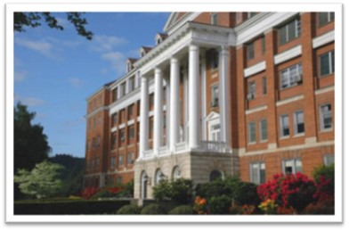

**Roseburg VA Health Care System**

**is recruiting for three positions for our ASHP-accredited**

**PGY-1 Pharmacy Residency Program!**

**Visit us at the ASHP Midyear Clinical Meeting Residency Showcase**

**Monday, December 9th, 1pm-4pm**

**Booth #4439**

**NMS Code: 203713**

**Application deadline: January 1st**

**Link:**

PGY-1 Residency Brochure

<https://www.roseburg.va.gov/pharmacyresidency>

**Purpose:**

The Roseburg VA Health Care System residency program has an emphasis on ambulatory care, but still includes inpatient settings as well as the ability to customize research and learning experiences to meet residents' needs. The purpose of this program is to develop pharmacists’ skills in disease state management, pharmacy administration and quality improvement. Residents will work alongside board-certified pharmacists with prescriptive authority and be able to actively participate in patient management in a variety of clinical settings. Upon completion, residents will be qualified to practice in primary care or be prepared for PGY-2 training to specialize in their field of choice. Additionally, the resident will have an opportunity to early commit to the PGY-2 Ambulatory Care residency at the Eugene VA Health Care Center.



***Rene Endow-Eyer, Pharm.D., BCPP***

PGY-1 Pharmacy Residency Program Director

Clinical Pharmacy Specialist, Mental Health

(541) 440-1000 x45095

[Rene.Endow@va.gov](mailto:Rene.Endow@va.gov)

Be sure to stop by our booth at ASHP Midyear Clinical Meeting to inquire about all the rotations and experiences we have to offer. Our residency program director, Rene Endow-Eyer and current PGY-1 Pharmacy Residents: Vivian Chau, Leah Isip and Foua Xiong will be there to answer your questions. You may also email [VHAROS-PharmResidency@va.gov](mailto:VHAROS-PharmResidency@va.gov) with questions about our program. We hope to see you in Las Vegas!

Best regards,

**Vivian Chau, Pharm.D.**