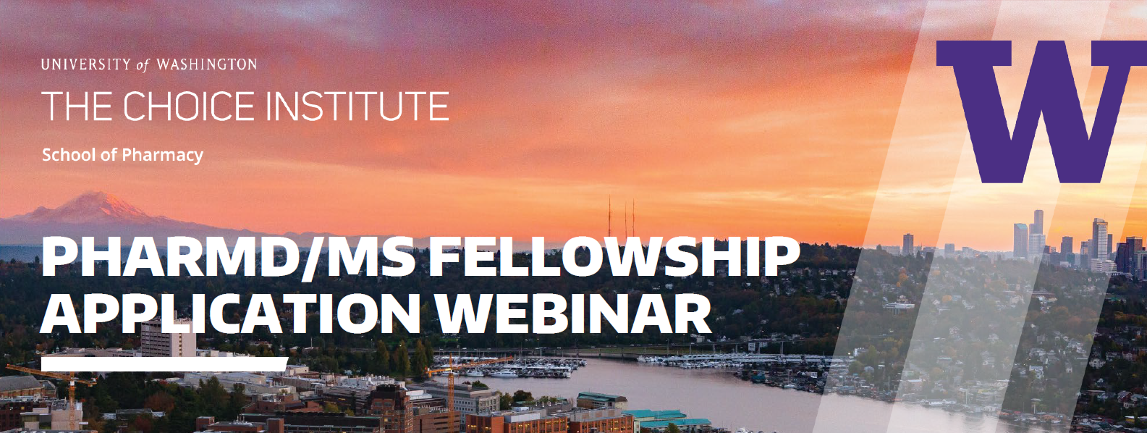

4th Year Pharmacy Students!

Please join us for an informational webinar featuring the exciting PharmD/MS Fellowship Opportunities at the Comparative Health Outcomes, Policy and Economics (CHOICE) Institute of the University of Washington School of Pharmacy. These training programs in health economics, outcomes research, and policy each combine the resources of a leading academic center for pharmaceutical economics and policy with the dynamic, real-world training of major pharmaceutical and biotechnology companies recognized for their commitment to innovation.

We offer fellowships with 4 industry partners:
- Allergan
- Bayer
- Genentech
- Seattle Genetics

Our current fellows are hosting a webinar to introduce you to these 2-year programs.

Date: Wednesday, October 23
Time: 5 pm to 6 pm Pacific Time

Registration is required (limited to 100)! Please register at this link.

After registering, you will receive a confirmation email with instructions on joining the meeting. This webinar will be recorded and posted for those unable to attend.

Contact Marina Gano, Graduate Program and Operations Manager, with questions: mcgano@uw.edu.

