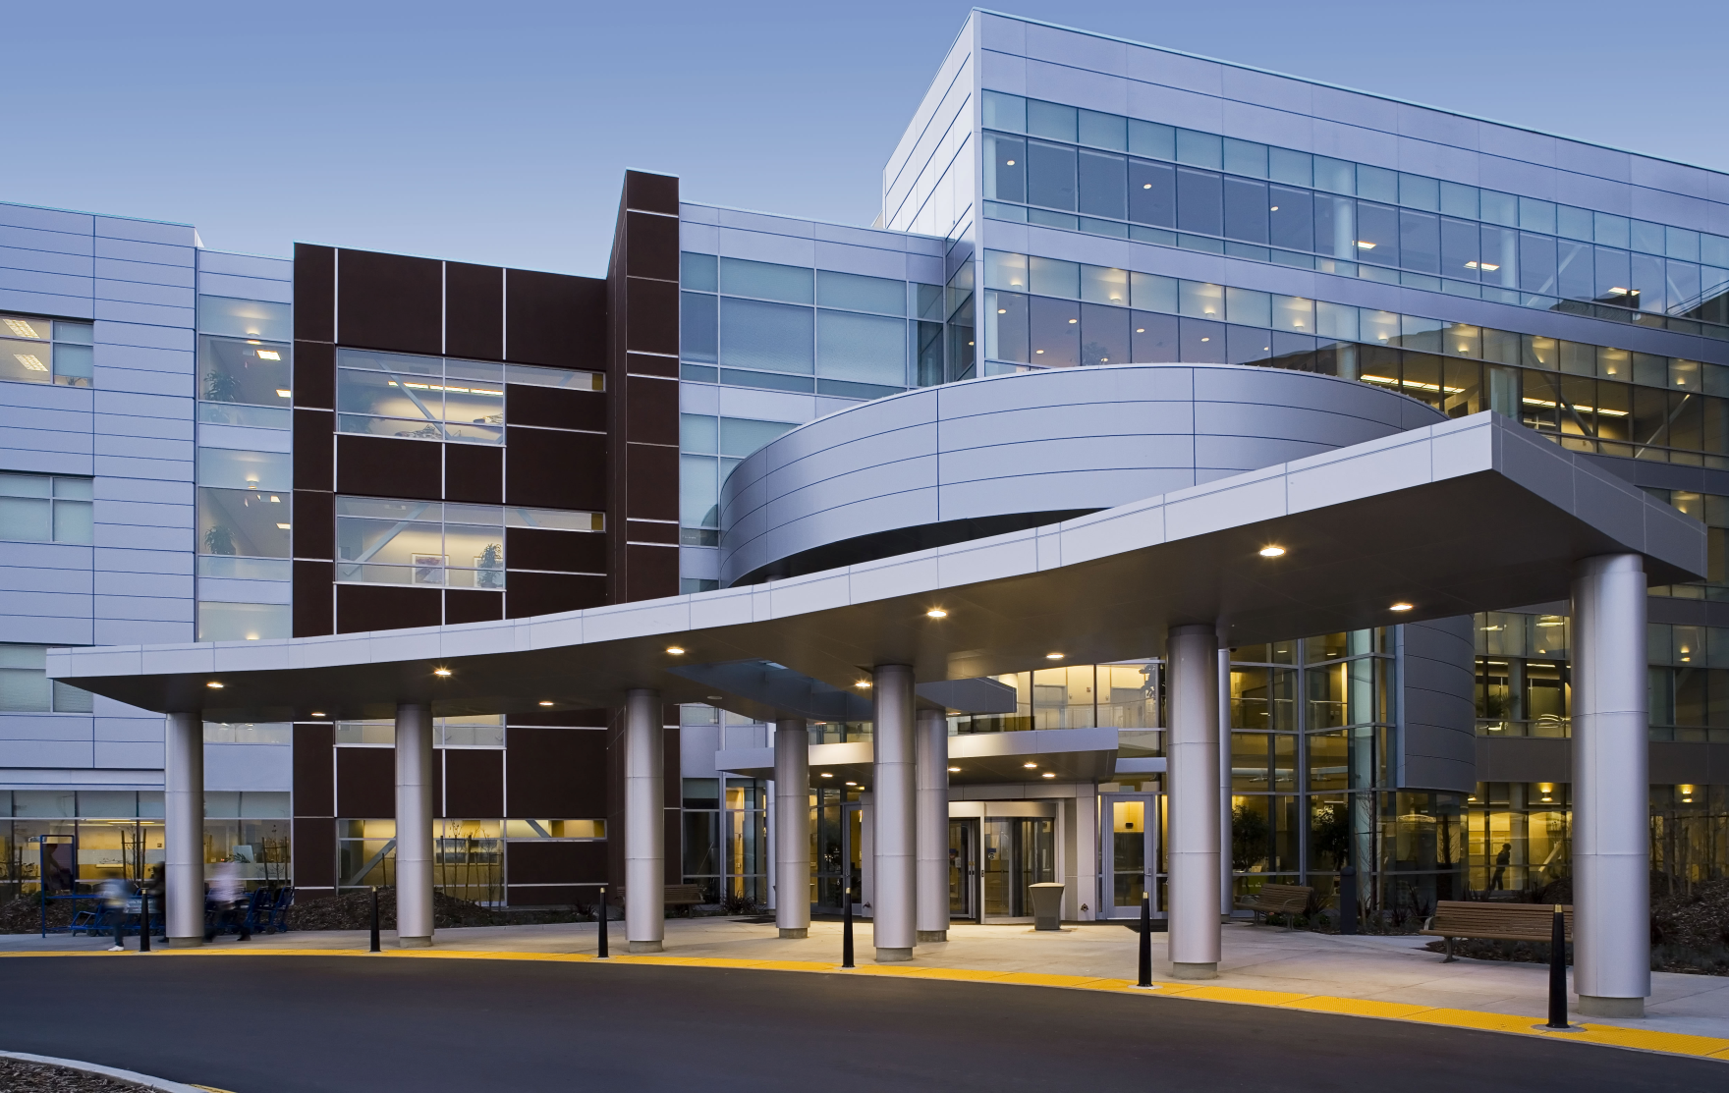

# Kaiser Permanente

# Diablo Residency Program

# Open House

# 12/09/19

# 2:30 - 5:00pm

# Walnut Creek, CA

`

RSVP by 12/02/19 to [Kayla.x1.galanter@kp.org](mailto:Kayla.x1.galanter@kp.org)

# 1425 South Main St.

# Medical Office Building

# Oak 1 & 2 Conference Rooms

# Walnut Creek, 94596