Tips for Finding the Perfect Residency Match
FEBRUARY 13, 2019
This article is the author's opinion and is not intended to guarantee, secure, solidify, or assure a successful match.
For fourth-year residency candidates across the nation, January through March can be a whirlwind of presentations, program overviews, panels, and a plethora of questions. It’s a time of clinical skill assessment and communicating how you see yourself aligning with the goals and objectives of the program. You may have the opportunity to interact with the residency program director, residents, clinical preceptors, and more.
I have yet to interview at a place where I’ve interacted with fewer than 10 people throughout the day. Ten people can give rise to both 10 perspectives and 10 or more opportunities to connect.
The goal of the residency interview is to find the right fit. If you’ve been selected for an interview, you’re qualified in the eyes of the program. You ‘look good on paper.’ Those who are selected to interview along with you likely have similar qualifications.
Your hard work over the past 4 years gets you through the doors. However, the factors for granting an onsite interview are vastly different from those considered in the ranking of candidates.
In 2012, the American Journal of Health-System Pharmacy published results of a survey, completed by 377 residency program directors across the nation, which sought to determine the factors that programs use to select residents for an onsite interview and ranking. The factors which were most commonly considered important for granting an interview were the perception of the candidate’s ability to learn, a recommendation from employers or preceptors in pharmacy practice, and previous work experience. For ranking of candidates, compatibility with the program, commitment to hard work, and ability to work with a team were most often considered critical. This shift from the objective to subjective is intended to ensure that the time the candidate spends at the institution is mutually beneficial and seeks to identify the right fit.
The concept of ‘fit’ may be difficult for those who have not experienced the process to understand. Well-meaning family and friends may ask which place is ‘the best.’ This can also be subjective for the candidate. Though reputation, history, and values are important, hospitals may be evaluated by different entities each year and rankings should not be the only thing to consider when finding the ideal program.
In the ever-changing field of health care, I consider the best facilities to be those which value an ongoing commitment to patient outcomes and progress. I feel that the best place for me is one which shares my patient-centered approach to care, which is open to embrace changes that enhance patient care, and a place which fosters an environment of professional collaboration.
As an applicant, there are ways to identify which place is best for you. However, this does require some preparation and later introspection.
A common suggestion is to schedule the places which you are most interested in at a later date to allow for practice. However, due to the increasingly competitive nature of pharmacy residencies, applicants are applying to more and more programs. Interviews may be offered from January through March, but programs often offer dates which fall within a much shorter window. Considering timing is good advice, but candidates must also work with the dates offered by each program. In an ideal world, we could interview at our most esteemed institutions when we feel more prepared and polished. In reality, you may have some control, but must also work with the hand you are dealt.
Mock interviews are a great opportunity to shake off some jitters and reflect. However, a true reflection of a pharmacy residency interview would require 4-8 hours with a large team of people. My first interviews were esteemed institutions, and I did not have the luxury of a ‘practice run.’ However, I am genuinely interested in each of the programs I chose to apply to and feel it would be an insult to the institution to deliberately schedule an interview for the sake of practice.
The interview offers you 1 day to assess your compatibility with the program for an entire year. This decision is not and should not be taken lightly by the candidate or the program. My hope is that I will be evaluated on my capabilities as a clinical pharmacist, team member, and educator. I hope to match with a program that values my work ethic, positive attitude, and dedication to optimizing patient care.
In closing, know the program and know yourself. Seek to find an environment where you will be both supported and challenged to grow. Reflect. Be respectful to the program and its people. Be professional. Be yourself. You may fit in, you may not. That is what the interview day is all about. If you’re there, you are qualified to do the job. Ask yourself which program will help you to become the best clinical pharmacist you can be, not just in terms of content knowledge but applicability of this knowledge, transferability to your future career, and personal satisfaction.
Though the matching algorithm may be unequivocally objective and impersonal, it is my belief that passion is what makes the best pharmacists. Better pharmacists provide better patient care. Reflect on the places that motivate and inspire you, and may the odds be ever in your favor.
Reference
Gair, R. Factors used by pharmacy residency programs to select residents. Am J Health-Syst Pharm. 2012;69(1):1105-1108.
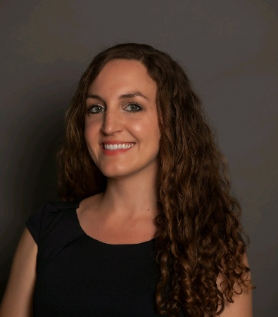
Adriana Hughes, PharmD Candidate 2019
Adriana Hughes is a PharmD Candidate of the Class of 2019 at the University of South Florida (USF) College of Pharmacy with clinical internship experience in the ICU and Emergency Department. She also enjoys writing and has been a contributing writer for Pharmacy Times since 2016. She is currently pursuing a PGY1 with robust experiences in critical care, emergency medicine, academia and which offers diverse learning experiences.

